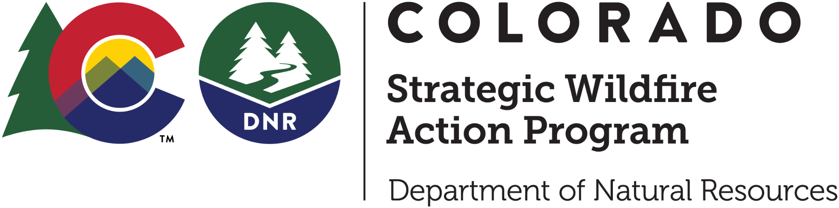

# COSWAP Workforce Development Grant Application:

# Wildfire Mitigation Workforce Training

Colorado Department of Natural Resource’s Strategic Wildfire Action Program (COSWAP) has funding available to support wildfire mitigation workforce training statewide. COSWAP supports trainings that are new to your workforce and add tangible value. Eligible training opportunities are listed in the Request for Applications found on the [COSWAP website](https://dnr.colorado.gov/divisions/forestry/co-strategic-wildfire-action-program). Please contact COSWAP staff if you have questions about whether the training you are requesting is eligible.

## Contact Information

If you have any questions regarding this application, please contact DNR staff:

Roberta Anderson Courtney Young

Program Assistant Program Administrator

roberta.anderson@state.co.us courtney.young@state.co.us

## How to Apply

Applicants should review the Request for Applications (RFA) before filling out the application. The RFA includes important information on eligibility, timeline, and process.

Applicants should submit a completed application combined into a single pdf file to coswap@state.co.us with “COSWAP-Application-*Your Project Name*” in the subject line. Hard copies will not be accepted. You should receive an email confirmation of your submission within 1 week. If you do not hear back about your application within 1 week, please contact Roberta Anderson.

All applicants are required to communicate with the potential trainees or organizations listed on the grant application before submitting their proposal.

# COSWAP Workforce Development Grant Application:

# Wildfire Mitigation Workforce Training

**Applications must be submitted by email to coswap@state.co.us** and will be accepted until November 1, 2024.

| Project name: | | Date: |
| --- | --- | --- |
| Applicant Information | | |
| Organization name (entity legally responsible for the project): | | |
| Project Manager: | Title: | |
| Mailing address/City/State/Zip: | | |
| Telephone (Work/Cell): | | |
| Email: | | |

| Cash Grant Details Please check which wildfire mitigation training opportunity you are applying for. If the training is not listed, please check ‘Other’ and provide the name and detailed description. | |
| --- | --- |
| * S-130/S-190/L-180 Basic Firefighting and Wildland Fire Behavior * S-212 Powersaws * Prescribed Fire Training Exchange (TREX) * Fire Department Training Exchange (FDX) * NFPA Certified Wildfire Mitigation Specialist * Community Wildfire Mitigation Best Practices (USFS and Coalitions & Collaboratives) * Building Your FAC Neighborhood Ambassador Approach (FACO and Wildfire Adapted Partnership) * DFPC's Colorado Certified Burner/ Burn Boss * Field training for prescription development and treatment implementation * Advanced tree felling * Other: Please explain __________________________________________________________ | |
| Cash Grant for Mitigation Questions | |
| Briefly describe your organization and your role in wildfire mitigation. What local and/or regional partnerships are you affiliated with? | |
| Is your organization located in an area at high or highest risk to wildfire as identified in the [CSFS Wildland-Urban Interface (WUI) Risk Index](https://co-pub.coloradoforestatlas.org/#/)? If your community has a localized risk assessment, share a link. | |
| List the number of trainees for each of the trainings applied for: | |
| What are the trainees' relationships to your organization? | |
| Who will be conducting the training? Please include details on curriculum or training content. How long will the training be hosted for? | |
| Demonstrate the need for this training. | |
| What is the short term outcome of this training opportunity? List wildfire mitigation opportunities that trainees will be participating in because of this training. | |
| What is the long term vision for utilizing this training and those trained? | |
| Please explain how the training will increase the mitigation workforce. | |

| Cash Grant Budget | | | | |
| --- | --- | --- | --- | --- |
| The maximum cash award for wildfire mitigation workforce training is $100,000. Up to 10% of the request may be used for indirect costs. Applicants must provide a 25% match of the award amount, except for Tribal entities who are exempt from the match requirement.  **Project Categories**   * Personnel time: Amount needed for personnel to attend training * Training cost: Actual cost of the wildfire mitigation workforce training program or cost of the instructor * Travel expenses: Mileage, hotel and GSA approved per diem associated with attending the training * Indirect: Indirect costs are the expenses of doing business that are not readily identified in the grant budget. Indirect cannot exceed 10% of the total requested from COSWAP. | | | | |
| **Match**  Column C + D totals must equal at least 25% of column B total.  Match (In-kind): Personnel time, equipment usage, training cost, travel expenses, etc.  Match (dollars): Cash | | **Match Calculator**  If requesting $10,000 a $2,500 match is required.  If requesting $50,000 a $12,500 match is required.  If requesting $100,000 a $25,000 match is required. | | |
| **A** | **B** | **C** | **D** | **E** |
| **Project categories** | **Grant share**  **(Amount requested)** | **Match**  **(In-Kind)** | **Match**  **(Dollars)** | **Total** |
| Personnel time |  |  |  |  |
| Training cost |  |  |  |  |
| Travel expenses |  |  |  |  |
| Indirect (max 10%) |  |  |  |  |
| **Total Budget** |  |  |  |  |

| Cash Grant Budget Narrative Please describe each of the project categories in detail below. Include details for both the grant share and match.  If applicable, please explain if there will be other funding sources contributing to the cost of the training so it is clear that there is no duplication of payments. |
| --- |
|  |

| Agreement, Liability, and Insurance Acknowledgements | | |
| --- | --- | --- |
| ☐ I understand that all successful applicants will be required to enter a Grant Agreement with the State of Colorado as a condition of receiving the grant award. I have reviewed the Grant Agreement sample template found on the COSWAP webpage.  ☐ I understand that all successful applicants must agree to assume all liability related to the approved project and to indemnify and hold harmless the State of Colorado for any and all claims arising out of the approved project. I agree that the State will not be liable for any act or omission of any party as a part of an approved grant program that causes any harm or that fails to prevent or mitigate wildfire damage at any time in the future.  ☐ I understand that all successful applicants will be required to maintain and provide proof of adequate insurance coverage as detailed in the Grant Agreement. I agree to acquire and maintain such insurance coverage as a condition of any grant award. | | |
| Authorized Signature | | |
| I certify that I am authorized to sign on behalf of the applicant and that, if awarded a grant for this project, the applicant will comply with the grant administration requirements of the State. I certify that the contents of this application are true to the best of my knowledge and agree to provide any corrections or updates to the State as soon as practical after discovery of an error. | | |
| Signature (Electronic and PDF Signatures are accepted; unsigned applications will not be accepted): | | |
|  | | |
| Name: | Title: | Date: |