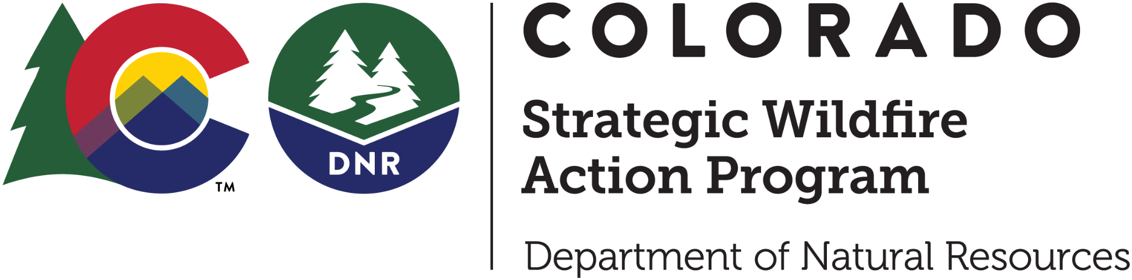

# COSWAP Workforce Development Grant

# 2025 Request for Applications

## Table of Contents

Table of Contents 1

Program Information 2

Grant Timeline 2

Grant Overview 2

Eligibility 3

1. Applicants 3

2. Land Ownership Types 3

3. Strategic Focus Areas and Project Locations 3

4. Projects and Trainings 4

5. Expenses 5

COSWAP Workforce Development Grants Navigation Chart 6

COSWAP Workforce Development Grants 7

1. Wildfire mitigation work completed by a CYCA accredited conservation corps 7

2. Wildfire mitigation work completed by an independent conservation corps 8

3. Wildfire mitigation work completed by DOC SWIFT crews 8

4. Wildfire mitigation workforce training 9

Process 10

1. Application 10

2. Evaluation and Ranking 10

3. Award Process 10

4. Reimbursement Process 10

5. Reporting Requirements 10

Grant Agreement, Liability, Insurance, and Indemnification 11

Supplemental Information 11

Appendix A: Working with CYCA Accredited Conservation Corps and DOC SWIFT crews 12

Appendix B: COSWAP Ranking and Scoring Sheets 13

2025 Workforce Development Ranking Criteria - Mitigation Projects 13

2025 Workforce Development Ranking Criteria - Trainings 15

## Program Information

The Colorado Strategic Wildfire Action Program (COSWAP) is a permanent state-funded program designed to support wildfire risk reduction in Colorado to protect life, property, and infrastructure. COSWAP addresses the urgency of reducing wildfire risk through workforce development and landscape-scale fuels reduction projects.

If you have questions about the COSWAP program, please contact:

Courtney Young, Program Administrator

[courtney.young@state.co.us](mailto:courtney.young@state.co.us)

Roberta Anderson, Program Assistant

[roberta.anderson@state.co.us](mailto:roberta.anderson@state.co.us)

For more information and to access grant applications, visit the COSWAP website: <https://dnr.colorado.gov/divisions/forestry/co-strategic-wildfire-action-program>.

## Grant Timeline

* September 8, 2025 - Application Release
* November 3, 2025 - Applications Due
* December 2025 - Grants Awarded and Contract Administration Begins
* December 31, 2027 - Project/Training Completion Deadline

## Grant Overview

COSWAP’s Workforce Development Grant provides supported, entry-level, hands-on experience and training opportunities for individuals interested in wildfire mitigation and forestry. The Workforce Development grant is **a two-year grant that will be offered every other year**. We encourage applicants to submit proposals for projects that span the next two years so there will not be a gap in work completed before the next round of funding becomes available again.

The COSWAP workforce development program offers four separate grants:

1. **Wildfire mitigation work completed by a** [**CYCA accredited conservation corps**](https://www.cyca.org/hire-a-corps/)**.**

1. **Wildfire mitigation work completed by an** [**independent conservation corps**](https://corpsnetwork.org/about-us/what-is-a-corps/)**.**

According to The Corps Network, conservation corps are locally-based organizations that engage young adults (generally ages 16–30) and veterans in service projects that address recreation, conservation, disaster response, and community needs. Independent conservation corps must be located in Colorado.Please contact COSWAP staff if you have questions about whether an organization you are requesting to work with is a conservation corps.

1. **Wildfire mitigation work completed by** [**DOC SWIFT crew**](https://cci.colorado.gov/swift)**.**
2. **Wildfire mitigation workforce training.**

## 

## Eligibility

### 

### 1. Applicants

#### Eligible applicants:

* Federal agencies
* State agencies (Projects on state trust land must be cleared by the State Land Board Conservation Services Manager, [mindy.gottsegen@state.co.us](mailto:mindy.gottsegen@state.co.us), before applying)
* Local governments including counties, municipalities, fire protection districts and other special districts
* Tribes
* Public utilities with infrastructure or land ownership in areas of high wildfire risk
* 501(c)(3) Non-profit organizations that promote fuel reduction projects, are engaged in prescribed fire, or natural resource management including wildfire councils and/or wildfire, watershed, or forest collaboratives

#### Ineligible applicants:

* Individual property owners, homeowners associations, property owners associations, formal neighborhood associations, or road districts

### 

### 2. Land Ownership Types

Funding can be used on **all land ownership types** throughout Colorado.

### 

### 3. Strategic Focus Areas and Project Locations

#### Conservation Corps

CYCA accredited or independent conservation corps projects must fall within COSWAP’s **Strategic Focus Areas**\*. 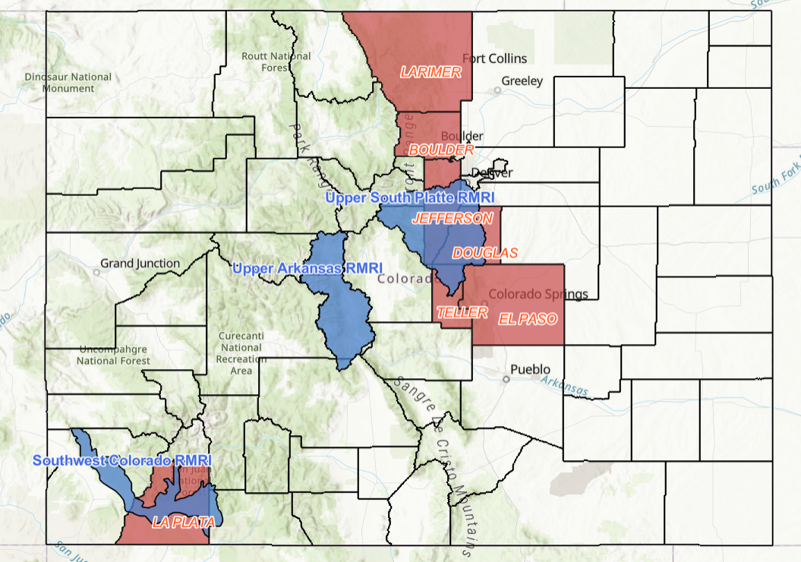

1. Boulder County
2. Douglas County
3. El Paso County
4. Jefferson County
5. La Plata County
6. Larimer County
7. Teller County
8. [Rocky Mountain Restoration Initiative](https://restoringtherockies.org/#maps) Focal Areas (in blue)
   1. Southwest Colorado (Parts of Dolores, Montezuma, and La Plata Counties)
   2. Upper Arkansas (Chaffee and Lake Counties)
   3. Upper South Platte (Parts of Arapaho, Clear Creek, Douglas, Jefferson, Park and Teller Counties)

*\*Understanding that strategic wildfire mitigation may need to cross county boundaries, up to 50% of a project may be outside a Strategic Focus Area if the work is contiguous with the proposed treatment or an area already mitigated.*

#### DOC SWIFT Crews

DOC SWIFT crews are only available within a 3 hour drive of the Four Mile Correctional Facility in Cañon City (E US Highway 50 & Evans Rd, Cañon City, CO 81212).

#### Trainings

Awards made for wildfire mitigation workforce training are available **statewide**.

### 4. Projects and Trainings

#### Eligible project activities include, but are not limited to:

* The creation or maintenance of fuel breaks, based on the current [CSFS guidelines](https://static.colostate.edu/client-files/csfs/pdfs/fuelbreak_guidellines.pdf).
* Fuels reduction designed to protect communities, infrastructure, water supplies, and/or reduce potential fire intensity.
* Chipping, as appropriate for hand crews, based on the current [guidelines](https://cfri.colostate.edu/wp-content/uploads/sites/22/2020/02/FRRT-Mulching-Knowledge-Summary-and-Implementation-Guidelines-1.16.20.pdf), speak to the workforce partner about chipper availability.
* Pile and broadcast burning, based on the [Division of Fire Prevention and Control (DFPC) guidelines](https://drive.google.com/file/d/12f8PZ8OG4aQkdGpju8x6LVms_GiuXgyk/view?usp=sharing). Select workforce crews have received [Type 2 Firefighter certifications](https://www.nwcg.gov/positions/firefighter-type-2-crewmember/qualification-requirements); speak to the crew managers if looking for burning assistance. Pile and broadcast burn projects need to comply with local and state permitting requirements.

#### Ineligible projects:

* Defensible space projects.
* Projects in close proximity to powerlines and structures.
* Projects that span multiple private landowners will be considered on a case by case basis.

Applicants are able to apply for a project continuation from a previous COSWAP grant. However, applications will not be accepted that have the exact same map and scope of work as the previous application. Please include a map of what was previously completed with COSWAP funds and describe how the scope of work has evolved.

#### Strategic project requirement:

Proposed projects must be strategic to maximize the effectiveness of this program. Applicants will be required to describe the strategic nature of the project in the application narrative. Examples of strategic elements include:

* Projects that reduce hazardous fuels directly adjacent to communities and provide safe access routes to communities (fuelbreaks, ingress/egress*, maintenance treatments).
  + *\*Roadside mitigation will be awarded on a case by case basis. Projects must follow the* [*Colorado State Forest Service (CSFS) standard*](https://static.colostate.edu/client-files/csfs/pdfs/fuelbreak_guidellines.pdf) *of at least a 150 ft wide treatment.*
* Projects adjacent to or within close proximity to lands that have been recently treated or are planned for treatment.
* Projects that are part of a larger landscape-scale treatment effort.
* Projects that protect critical infrastructure including evacuation routes, critical watersheds, healthcare facilities and emergency services.

#### Additional consideration will be given to projects that contain elements listed below:

* Projects identified in a local or county Community Wildfire Protection Plan (CWPP), completed Wildfire Read Action Plans, FEMA Hazard Mitigation Plan, or identified through a collaborative group or process. Approved CWPPs can be found on the [CSFS website](https://csfs.colostate.edu/wildfire-mitigation/community-wildfire-protection-plans/).
* Projects that result in the protection of water supplies.
* Projects that benefit communities of high social vulnerability.
* Collaborative planning efforts.
* Projects that leverage interagency resources or equipment.

#### Eligible wildfire mitigation workforce trainings include:

* S-130/S-190/L-180 Basic Firefighting and Wildland Fire Behavior
* S-212 Wildland Fire Chainsaw Operations
* Prescribed Fire Training Exchange (TREX)

### 5. Expenses

**Mitigation Projects: Cash Award Eligible Expenses**

* Mitigation work completed by an independent conservation corps
* Project management expenses including personnel time (up to 10 hours a week), biomass expenses including chipper rental, porta-potties, camping fees, herbicide, etc.

**Mitigation Projects: Cash Award Ineligible Expenses**

* Hiring a full-time Wildfire Mitigation Specialist or mitigation crew
* Purchasing equipment and supplies (equipment rental is eligible)
* Post treatment restoration including native seeds and pest control
* Hardware, software, technology, office supplies, printing, uniforms, etc.
* Programing and/or outreach
* Food and beverage
* Mileage, hotel and per diem for overnight travel

**Trainings: Eligible Expenses**

* Personnel time to attend training
* Cost of the wildfire mitigation workforce training tuition
* Cost of the instructor to host the training (hours spent with students), instructor hours spent preparing for the training (up to 10 for S130/190 & S212)
* Equipment rental
* NWCG designated course materials- printed at a shop or ordered
* 2025 Federal mileage reimbursement ($0.70), hotel and [GSA approved per diem](https://www.gsa.gov/travel/plan-book/per-diem-rates) for overnight travel to a training

**Trainings: Ineligible Expenses:**

* Supplies, equipment purchases and personal protection equipment
* Fully online training courses
* Hardware, software, technology, office supplies, uniforms, etc.
* Programming and/or outreach
* Food and beverage

Cash grant applications are required to provide at least 25% cash or in-kind match, except for Tribal entities who are exempt from the match requirement. Applicants can request an indirect fee up to 10% of the cash grant to cover administrative costs with no reporting requirements. Applicants must complete the budget provided in the application.

## COSWAP Workforce Development Grants Navigation Chart

Use the chart below to help determine which grant is most appropriate for your needs. Other eligibility requirements are listed on pages 3-5.

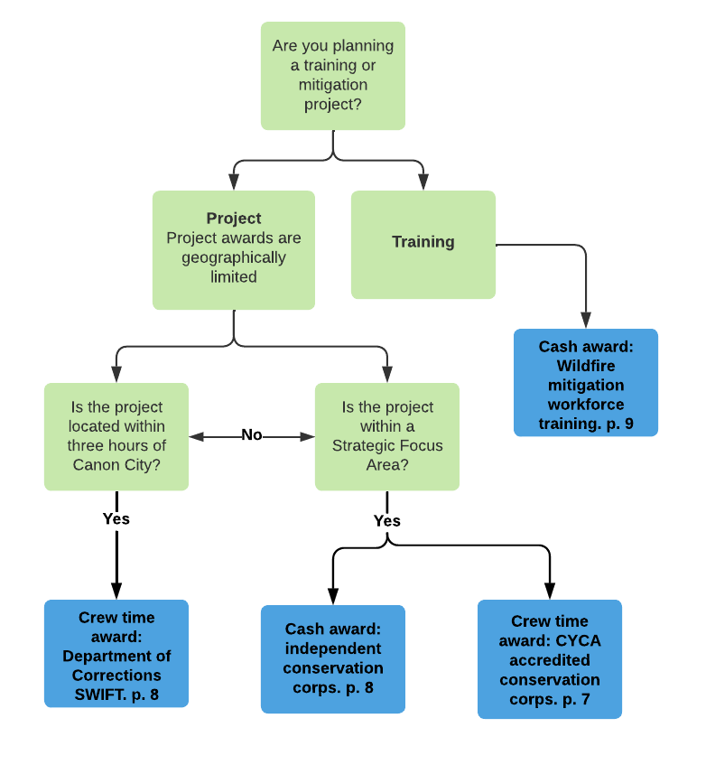

## COSWAP Workforce Development Grants

Below are the four grants that the COSWAP Workforce Development program offers.

*COSWAP cannot guarantee that work completed as a result of either crew time or cash awards will prevent or minimize the damage from future wildfires. COSWAP will not guarantee the effectiveness or outcomes of any approved project. COSWAP will review proposals and evaluate them based on ranking criteria. COSWAP reserves the right to suggest edits to and/or negotiate both the scope and budget of proposals to bring projects in line with COSWAP's programmatic goals.*

### 1. Wildfire mitigation work completed by a [CYCA accredited conservation corps](https://www.cyca.org/hire-a-corps/)

All applicants are required to reach out to their local corps before submitting their proposal. You can find a map showing where each corps is located, and the project development contact for that corps, on CYCA’s website:<https://www.cyca.org/hire-a-corps/>.

The [Ancestral Lands Conservation Corps](https://ancestrallands.org/) is also now eligible for crew time awards.

#### Crew time award:

Applicants can have wildfire mitigation work performed by a CYCA accredited conservation corps through a crew time award. A crew time award is contracted by weeks of service and can range from 6-25 weeks of work. A crew is typically (but not always) up to 8 members and completes 320 hours of work a week.

Applicants requesting CYCA accredited conservation corps must provide project management and oversight. Applicants must make a staff member or site supervisor available to meet with crews, identify the project boundaries, review the treatment prescription, supervise work onsite as needed to ensure corps work is satisfactory before moving forward, and to collect pre- and post-treatment information for reporting.

Please reference ‘Appendix A: Working with CYCA Accredited Conservation Corps and DOC SWIFT crews’, for more information on shared responsibilities and expectations for project managers.

#### Cash award:

In addition to crew time awards, applications for CYCA accredited conservation corps can also request a cash grant for project management expenses. A list of eligible and ineligible expenses can be found on page 5.

#### What makes a good CYCA project?

Successful projects with CYCA accredited conservation corps have a clear and achievable scope of work. Crew members value on-the-ground training and continued check-ins throughout the duration of the project. Although crews contain at least one member that can fell larger trees, projects with smaller trees and less complex treatments tend to be the most successful. Crews can be an excellent complement to a contractor or agency crew who is completing the more complex aspects of a project. A COSWAP award with CYCA has a dual focus of workforce development and wildfire mitigation, as CYCA embodies core values of providing education and career training opportunities.

***Disclaimer:*** *Projects are awarded on a per week basis and cannot guarantee project completion. Projects are deemed complete when the weeks awarded are fulfilled.*

### 2. Wildfire mitigation work completed by an [independent conservation corps](https://corpsnetwork.org/about-us/what-is-a-corps/)

#### Cash award:

Applicants can have wildfire mitigation work performed by an independent corps utilizing a cash grant. The maximum grant award is $200,000. A list of eligible and ineligible expenses can be found on page 5.

Applicants requesting independent conservation corps must provide project management and oversight. Applicants must make a staff member or site supervisor available to meet with crews, identify the project boundaries, review the treatment prescription, supervise work onsite as needed to ensure corps work is satisfactory before moving forward, and to collect pre- and post-treatment information for reporting.

### 3. Wildfire mitigation work completed by [DOC SWIFT crew](https://cci.colorado.gov/swift)s

All applicants are required to reach out to the Department of Corrections SWIFT Supervisor about the project and if it is appropriate for DOC SWIFT crews. Questions can be directed to Greg Hawkins at gregory.hawkins@state.co.us, or by phone at 719-338-8052 (cell).

#### Crew time award:

Applicants can have wildfire mitigation work performed by the DOC SWIFT crew through a crew time award. DOC SWIFT crews are made up of incarcerated men with nonviolent sentences. A crew time award is contracted by weeks of service and can range from 6-25 weeks of work. A crew typically (but not always) consists of up to 20 men working Monday - Thursday or Tuesday - Friday.

Applicants requesting DOC SWIFT crews must provide project management and oversight. Applicants must make a staff member or site supervisor available to meet with crews, identify the project boundaries, review the treatment prescription, supervise work onsite as needed to ensure corps work is satisfactory before moving forward, and to collect pre- and post-treatment information for reporting.

Please reference ‘Appendix A: Working with CYCA Accredited Conservation Corps and DOC SWIFT crews’, for more information on shared responsibilities and expectations for project managers.

#### Cash award:

In addition to crew time awards, applications for DOC SWIFT crews can also request a cash grant for project expenses. A list of eligible and ineligible expenses can be found on page 5.

#### What makes a good DOC SWIFT project?

Projects utilizing DOC SWIFT are most successful when the project is located on larger tracts of land with limited landowners. Camping locations for DOC SWIFT need to be isolated away from the public.

Project managers working with DOC SWIFT need to be flexible with scheduling, crew size, and other project expectations. DOC SWIFT is likely to adjust work schedules throughout the year due to deployment to wildfires, personnel changes, and unforeseen circumstances. Awarded weeks are estimated for a single DOC crew. It is possible that a half crew, one and a half crew, or double crew works on a project for part or the entirety of the project. In this case, the number of calendar weeks spent on site may differ from the awarded weeks because the weeks are scaled up or down according to crew size. Projects may be completed in fewer weeks than contracted if the scope of work has been fulfilled.

***Disclaimer:*** *Projects are awarded on a per week basis and cannot guarantee project completion. Projects are deemed complete when the weeks awarded are fulfilled or the scope of work is completed, whichever occurs first.*

### 4. Wildfire mitigation workforce [training](https://www.nwcg.gov/nwcg-training)

Training is important to the development of Colorado’s wildfire mitigation workforce. COSWAP will provide cash grants to cover the cost of S-130/S-190/L-180 basic firefighter training, S-212 wildland fire chainsaw operations and Prescribed Fire Training Exchange (TREX) events. A list of eligible and ineligible expenses can be found on page 5.

Trainings are available for the following groups:

1. People employed in forest health or wildfire mitigation
2. Volunteer firefighters serving with a fire department or fire protection district
3. Volunteers who have shown their commitment to mitigation work previously and are completing mitigation beyond their own properties

This year trainers must be preidentified and qualifications noted in the application for review. All applicants are required to communicate with the potential trainees or organizations listed on the grant application before submitting their proposal.

Applications requesting funds for wildfire mitigation workforce training may not exceed $100,000. In the budget narrative, please explain if there will be other funding sources contributing to the cost of the training so it is clear that there is no duplication of payments.

## Process

### Application

The COSWAP Workforce Development Applications are available on the COSWAP website: <https://dnr.colorado.gov/divisions/forestry/co-strategic-wildfire-action-program>. Applicants are required to submit a complete application and map depicting the geographic location of the project. You should receive an email confirmation of your submission within 1 week. If you do not hear back about your application within 1 week, please contact Roberta Anderson (303-358-1344, [roberta.anderson@state.co.us](mailto:roberta.anderson@state.co.us)).

### Evaluation and Ranking

COSWAP will accept applications until November 3, 2025. Applications are reviewed by subject matter experts and DNR staff based on alignment with the program criteria. Review ‘Appendix B: COSWAP Ranking and Scoring Sheet’ for details.

### Award Process

For CYCA accredited conservation corps or DOC SWIFT crew applications, COSWAP staff will notify applicants of conditional award decisions via email by the end of November. Following a conditional award, the applicant must conduct a site visit with project partners within 3 weeks. Applicants are required to report back to DNR on the feasibility of the project, including the size, scope of work, and number of weeks requested. COSWAP will then determine whether or not to make an official award.

All applicants will be notified of official award decisions in December 2025, and may be contacted beforehand with clarifying questions regarding the application. Applicants must accept the award and reporting requirements before DNR initiates the grant agreement process. **No work can begin, or expenses incurred, until the grant agreement is signed and initiated.**

### Reimbursement Process

The Workforce Development cash grants are reimbursement grants and awardees must submit invoices to DNR up to once a month or at least once a year. COSWAP will only reimburse actual, incurred expenses; calculated or estimated expenses will not be accepted for reimbursement. Awardees must invoice DNR for all work completed within a state fiscal year by June 30th. An invoice template and instructions will be provided upon award. DNR will pay CYCA accredited conservation corps and DOC SWIFT crews directly, therefore crew time awards do not have a reimbursement process.

### Reporting Requirements

Awardees are required to submit quarterly progress reports to DNR and have 30 days after project completion to submit the final project report. Forms will be provided in the award package.

## Grant Agreement, Liability, Insurance, and Indemnification

All successful applicants will be required to enter a Grant Agreement with the State of Colorado as a condition of receiving the grant award. The Grant Agreement template is linked on [COSWAP’s website](https://dnr.colorado.gov/divisions/forestry/co-strategic-wildfire-action-program) for reference. All successful applicants must agree to assume all liability related to the approved project and to indemnify and hold harmless the State of Colorado, CYCA, DOC SWIFT, and any CYCA-accredited conservation corps for any and all claims arising out of the approved project. The State, CYCA, DOC SWIFT, and any CYCA-accredited conservation corps will not be liable for any act or omission of any party as a part of an approved grant program that causes any harm or that fails to prevent or mitigate wildfire damage at any time in the future. All successful applicants will be required to maintain and provide proof of adequate insurance coverage as detailed in the Grant Agreement.

## Supplemental Information

Information about Colorado’s wildfire risk to life, property, and infrastructure, via the Colorado Wildfire Risk Assessment (CO-WRA) is found on the Colorado State Forest Service Forest Atlas:

<https://coloradoforestatlas.org/>

Colorado State Forest Service guidelines for fuelbreaks:

<http://static.colostate.edu/client-files/csfs/pdfs/fuelbreak_guidellines.pdf>

Forestry Best Management Practices to Protect Water Quality in Colorado:

<http://static.colostate.edu/client-files/csfs/pdfs/ForestryBMP-CO-2010.pdf>

Mulching: A knowledge summary and guidelines for best practices on Colorado’s Front Range:

<https://research.fs.usda.gov/treesearch/62158>

Colorado Pile Construction Guide:

<https://drive.google.com/file/d/1aG_3NNK1Fp8kYJFW8CtWBGGkG1zDmN_g/view>

Division of Fire Prevention and Control Prescribed Fire Management Resources: <https://dfpc.colorado.gov/prescribed-fire-management>

## 

## Appendix A: Working with CYCA Accredited Conservation Corps and DOC SWIFT crews

Hosting CYCA accredited conservation corps and DOC SWIFT crews requires cooperation, communication, and shared responsibility. The breakdown below details how project managers, crews, and COSWAP generally share responsibility. Applicants should note in their applications any deviations from this general approach to the shared responsibilities that might be necessary for their particular project.

**Project Manager Responsibilities:**

* Project planning, and flagging project boundaries (if necessary)
* Pre-project site visit with crew staff
* Specialty tools (if necessary)
* Camping and porta-pottie logistics. Camping should be within 30 minutes of the project area.
* Project manager must be available for oversight and direction throughout the duration of the project. It is especially important to conduct regular check ins to ensure corps work is satisfactory before moving forward.
* Quarterly project reports
* Certify that the project is complete and report project metrics to DNR

**CYCA Corps and DOC SWIFT Crew Responsibilities:**

* Pre-project site visit with project manager
* Crew supervision
* Crew members
* Basic tools including chainsaws
  + DOC SWIFT crews and some CYCA accredited conservation corps have chippers available
* Transportation, food, and camping gear

**DNR, COSWAP Responsibilities:**

* Review applications, select projects, and execute contracts
* Pay CYCA accredited conservation corps or DOC SWIFT crews for their work
* Process reimbursement requests for cash grants
* Collect and review quarterly and final reports

## Appendix B: COSWAP Ranking and Scoring Sheets

*While a numerical evaluation method will be used as an aid, using the factors identified below, the selection ultimately is a program judgment that will reflect an integrated assessment of the relative merits of proposals.*

### 2025 Workforce Development Ranking Criteria - Mitigation Projects

The 2025 Workforce Development ranking for mitigation projects is based on the following criteria, out of a total of 100 possible points. A breakdown of scoring is as follows:

#### 

#### Program Criteria and Eligibility (Yes or No)

* Is this an eligible applicant/project manager?
* Is the project located in the Strategic Focus Areas? Or within 3 hours of the DOC SWIFT facility?
* Is this an eligible project?
* Is this prescription appropriate for the fuel type, location and workforce crew?
* Does the organization have the capacity to provide project management and oversight?

#### 

#### Organization Information (Max 5 Points)

* Is there a collaborative nature to this project?

#### 

#### Project Purpose & Objectives (Max 5 Points)

* Are the project objectives specific, measurable, achievable, and timely? Do they align with COSWAP's objectives?

#### 

#### Wildfire Risk Information (Max 10 Points)

* Is the project in a high risk area identified in [CO-WRA](https://co-pub.coloradoforestatlas.org/#/) or a local risk assessment? (5 points)
  + Score breakdown:
    - Project is within ½ mile or less from an area at high-risk (5 points)
    - Project is ½-2 miles from an area at high-risk (3-4 points)
    - Project is 2-5 miles from an area at high-risk (1-2 points)
* Is the project identified in a local or county CWPP, completed WRAP, or FEMA Hazard Mitigation Plan? (5 points)
  + Score breakdown:
    - This project is specifically identified in a plan with link and page number (5 points)
    - This project is generally specified in a plan (2 points)

#### 

#### Project Location (Max 25 Points)

* Community Protection (15 points)
  + Score breakdown:
    - Directly protects high density neighborhoods (15 points)
    - Directly protects medium density neighborhoods (10 points)
    - Directly protects low density neighborhoods (5 points)
* Does the project connect to planned or executed fuels reduction efforts? (5 points)
  + Score is dependent on proximity to project(s), status of project(s), size and number of project(s) and inclusion of the projects(s) on the required maps.
* Is the project within two miles of a socially vulnerable area? (5 points)
  + Score breakdown:
    - Project is within two miles of a socially vulnerable area (5 points)
    - Project is farther than two miles from of a socially vulnerable area (0 points)

#### 

#### Project Impact (Max 30 Points)

* Applicant has clearly described how the project is strategic and reduces wildfire risk to life and property (10 points)
* Critical Infrastructure (not water): Higher scores are given to more critical infrastructure and applications that more clearly describe the infrastructure and protection (10 points)
  + Score breakdown:
    - Protects multiple pieces of critical infrastructure: evacuation routes, communication towers, etc. (10 points)
    - Protects some critical infrastructure (5 points)
    - Protects other infrastructure of value (evacuation centers, parks) (<5 points)
* Is the project located in a [high priority subwatershed](https://fap2020.coloradoforestatlas.org/#/)? (5 points)
  + Score breakdown:
    - High priority subwatershed (5 points)
    - Low priority subwatershed (1 points)
* Applicant has clearly described how the project directly protects critical water infrastructure (5 points)
  + Scores will be dependent on specific impacts including named water infrastructure, soil erosion concerns, sediment buildup, water quality and accessibility, etc.

#### 

#### Project Maintenance (Max 5 Points)

* Project maintenance is funded, planned, and appropriate for the fuel type/prescription

#### 

#### Leveraged Funding and Resources (Max 5 Points)

* Does this project leverage outside funding or resources?

#### 

#### Scope of Work (Max 5 Points)

* Applicant provided a clear, detailed and appropriate plan and deadline for removing any woody material/slash generated

#### 

#### Budget (Max 5 Points)

* Budget quality and clarity (5 points)
  + Score breakdown:
    - Budget is incredibly detailed, the budget narrative is clearly explained and there are no follow up questions. Match is clearly defined. (5 points)
    - Satisfactory, budget adds up and all explanations are included (3 points)
    - Budget does not add up or is missing explanations for expenses (0 points)

#### 

#### Maps (Max 5 Points)

* Map quality and clarity (5 points)
  + Scores are dependent on maps containing the requested components and connectivity is clear

### 2025 Workforce Development Ranking Criteria - Trainings

The 2025 Workforce Development ranking for trainings is based on the following criteria, out of a total of 40 possible points. A breakdown of scoring is as follows:

#### Program Criteria and Eligibility (Yes or No)

* Is this an eligible applicant?
* Is this an eligible group of trainees?
* Is this an additional (rather than standard) trainings?
* Are the trainers qualified to provide this training?

#### Training Objectives (Max 5 Points)

* Are the training objectives specific, measurable, achievable, and timely? Do they align with COSWAP's objectives?

## 

#### Leveraged Funding and Resources (Max 5 Points)

* Does this project leverage outside funding or resources?

## 

#### Trainee Info and Impact (Max 15 Points)

* Training increases the forestry and mitigation workforce (5 points)
* Trainees have shown their commitment to wildfire mitigation (5 points)
* There is a clear plan for trainees to continue to engage in wildfire mitigation (5 points)

## 

#### Training Info (Max 5 Points)

* Applicant has clearly described the training location, timeline, and trainer qualifications.

## 

#### Preparation (Max 5 Points)

* The grantee has explained its ability to host or organize the relevant training
  + For TREX: TREX event is already being planned and coordinated with partners and resources to allow for success within the specified timeline
  + For in-house trainings: In-house offerings have explained their experience hosting this type of training.
  + For trainings at a facility: Facility trainings have begun coordination

#### Budget (Max 5 Points)

* Budget quality and clarity (5 points)
  + Score breakdown:
    - Budget is incredibly detailed, the budget narrative is clearly explained and there are no follow up questions. Match is clearly defined. (5 points)
    - Satisfactory, budget adds up and all explanations are included (3 points)
    - Budget does not add up or is missing explanations for expenses (0 points)